Assignment 2.1:
Summary Statistics:
- from the new weather data we can illustrate that:
- Outlook object: frequencies for sunny and overcast are the same: 5/14 =0.357
And the overcast is 4/14 = 0.2857.
- Temperature: Min = 64, Max = 85, Mean = 73.571 and the StdDev = 6.572.
- Humidity : Min = 65, Max= 96, Mean=81.643, StdDev =10.285
- Wind: 8 times are false and 6 times are true.
- Figure (1). Shows the visualization all the weather data.
- clustering:
- I used simpleKmeans for the attribute: outlook, windy, play where: K = 20, number of Iteration= 100, then I obtained the results in file (1) within cluster sum of squared errors: 0%. And when I changed K =10 I got the same results, since each point of (K), assigned to the closed centroid and each collection of point assigned to a centroid is a cluster, then with smaller iteration we can obtain the same clustering results, but, when the K = 5,
The clustering result within cluster sum of squared errors: 3.0% see file (2).
- next, I chose the attributes ,which are temperate and humidity and K = 20
I obtained the result in file (3), within cluster sum of squared errors: 0.0%, but, by reducing K = 4, then the results within cluster sum of squared errors: 1.0%
That means we need more points to have good clustering, see file (4).
- DBSCAN:
Here the important things are epsilon which is radius.
- (Eps) = 10, it should be higher enough because the small number of closely spaced points that are noise will be incorrectly labeled as clusters.
- Threshold MinPts = 4, because if it less than 7 then will indicated Core points.
I have chosen some attributes that I can get more useful for temperate and
humidity see figure (2), and visualized results in file (5).
4. Classification, j48:
The result in file (6) and see figure (3).
- ConjunctiveRule:
Which is simple conjunctive rule learner, the results in file (7) and see figure?
(4) for the classifier error
6. Decision table:
Which is build a simple decision table majority classifier, see file (8) and figure (5), from the confusion Matrix:
Correctly Classified Instances 9 64.2857 %
Incorrectly Classified Instances 5 35.7143 %
7. JRip:
Which is algorithm for fast, effective rule induction and it gives better results:
Correctly Classified Instances 11 78.5714 %
Incorrectly Classified Instances 3 21.4286 %
See file (9) and figure (6).
8. IB1:
It gives a good result when the cross validation only (12), otherwise it give 50 %
For both correctly and incorrectly classified. See file (10), this is when cross val.
Is (12), figure (7).
Correctly Classified Instances 9 64.2857 %
Incorrectly Classified Instances 5 35.7143 %
Otherwise: see file (11).
Correctly Classified Instances 7 50 %
Incorrectly Classified Instances 7 50 %
9.Kstar:
The best result I obtained when the cross validation is 9:
Correctly Classified Instances 10 71.4286 %
Incorrectly Classified Instances 4 28.5714 %
And if the cross validation is 11or 12 then:
Correctly Classified Instances 9 64.2857 %
Incorrectly Classified Instances 5 35.7143 %
And if the cross validation is 8 or less then the result is:
Correctly Classified Instances 9 64.2857 %
Incorrectly Classified Instances 5 35.7143 %
Otherwise they are equal:
Correctly Classified Instances 7 50 %
Incorrectly Classified Instances 7 50 %
10. NNge:
The best result when cross validation is 7, there the Correctly Classified is 78.5714 %
Correctly Classified Instances 11 78.5714 %
Incorrectly Classified Instances 3 21.4286 %
Kappa statistic 0.5116
Mean absolute error 0.2143
Root mean squared error 0.4629
Relative absolute error 45 %
Root relative squared error 93.8273 %
Total Number of Instances 14
I obtained the best results when cross validation are: 8 and 5
Correctly Classified Instances 8 57.1429 %
Incorrectly Classified Instances 6 42.8571 %
And when it is 9 the Correctly Classified is 64 %
Otherwise is 57%, see file (11) and see figure (8).
So when the cross validation is (6) the result is:
Correctly Classified Instances 7 50 %
Incorrectly Classified Instances 7 50 %
Kappa statistic 0.0392
Mean absolute error 0.5
Root mean squared error 0.7071
Relative absolute error 105.6385 %
Root relative squared error 144.7927 %
Total Number of Instances 14
In short NNge is the algorithm, which gives the best correctly classified
78.5714 %

Figure (1).
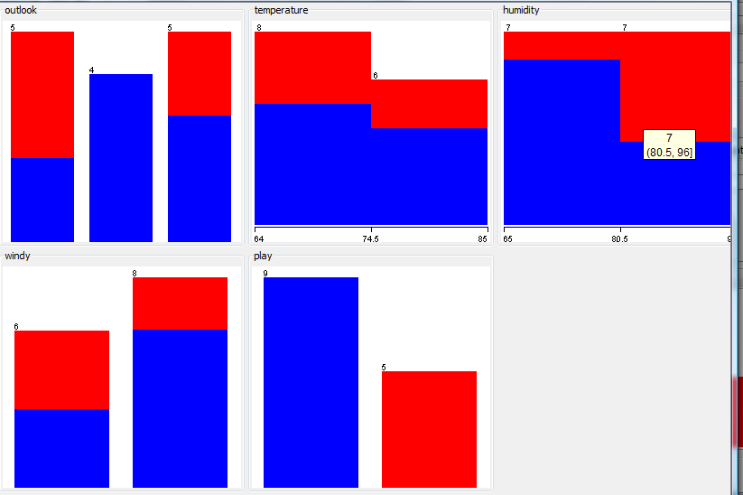

Figure (2).
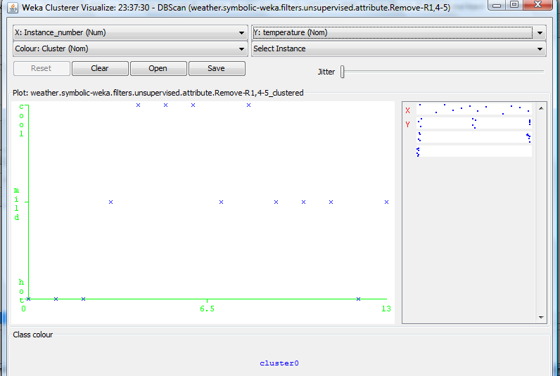

Figure (3).

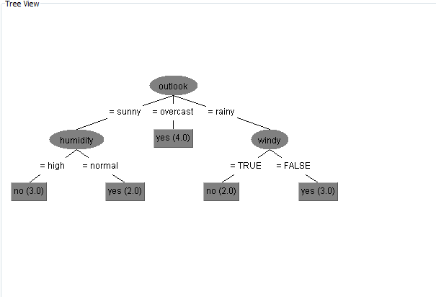

Figure (4).
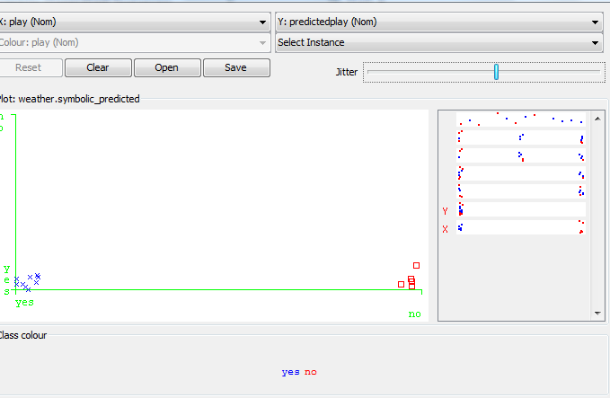
Figure (5).

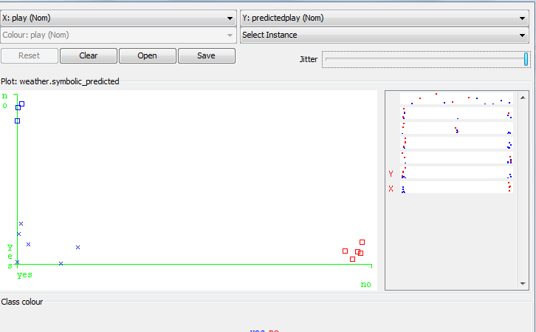

Figure (6).
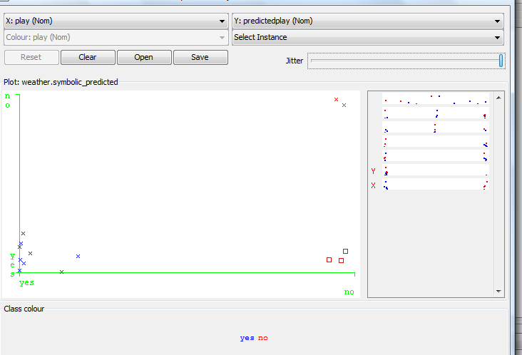

Figure (7).

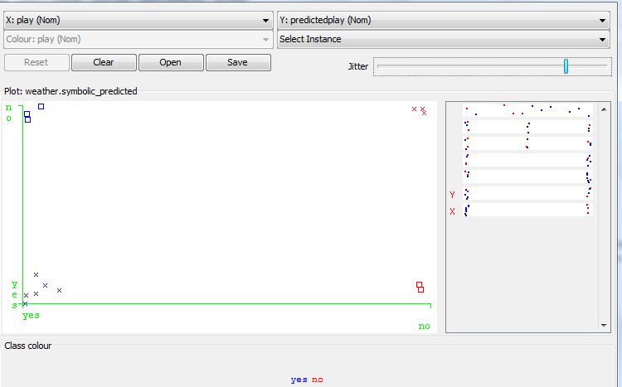

Figure (8).

